***Assignment 5***

**Question 1**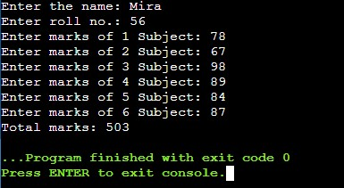

#include <iostream>

using namespace std;

class student{

char name[20];

int rollNo;

int marks[6];

public:

void getData();

float totalMarks();

};

void student::getData(){

cout<<"Enter the name: ";

cin>>name;

cout<<"Enter roll no.: ";

cin>>rollNo;

for(int i=0; i<6; i++){

cout<<"Enter marks of "<<i+1<<" Subject: ";

cin>>marks[i];

}

}

float student::totalMarks(){

float sum=0;

for(int i=0; i<6; i++){

sum += marks[i];

}

return sum;

}

int main()

{

student stu;

stu.getData();

cout<<"Total marks: "<<stu.totalMarks();

return 0;

}

**Question 2**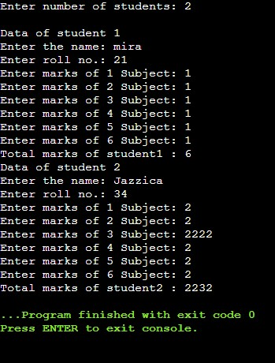

#include <iostream>

using namespace std;

class student{

char name[20];

int rollNo;

int marks[6];

public:

void getData();

float totalMarks();

};

void student::getData(){

cout<<"Enter the name: ";

cin>>name;

cout<<"Enter roll no.: ";

cin>>rollNo;

for(int i=0; i<6; i++){

cout<<"Enter marks of "<<i+1<<" Subject: ";

cin>>marks[i];

}

}

float student::totalMarks(){

float sum=0;

for(int i=0; i<6; i++){

sum += marks[i];

}

return sum;

}

int main()

{

int n;

cout<<"Enter number of students: ";

cin>>n;

student stu[n];

for(int i=0; i<n; i++){

cout<<"\nData of student "<<i+1<<endl;

stu[i].getData();

cout<<"Total marks of student"<<i+1 <<" : "<<stu[i].totalMarks();

}

return 0;

}

**Question 3**

#include <iostream>

using namespace std;

class manager{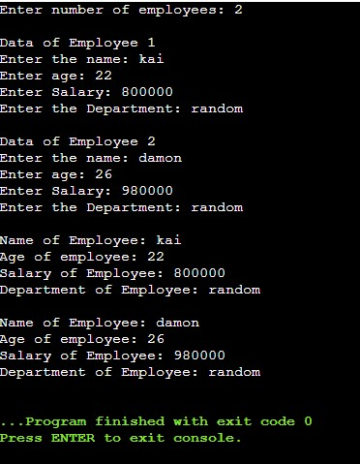

char name[20];

int age;

int salary;

char department[20];

public:

void getData();

void showDetails();

};

void manager::getData(){

cout<<"Enter the name: ";

cin>>name;

cout<<"Enter age: ";

cin>>age;

cout<<"Enter Salary: ";

cin>>salary;

cout<<"Enter the Department: ";

cin>>department;

}

void manager::showDetails(){

cout<<endl;

cout<<"Name of Employee: "<<name<<endl;

cout<<"Age of employee: "<<age<<endl;

cout<<"Salary of Employee: "<<salary<<endl;

cout<<"Department of Employee: "<<department<<endl;

}

int main()

{

int n;

cout<<"Enter number of employees: ";

cin>>n;

manager man[n];

for(int i=0; i<n; i++){

cout<<"\nData of Employee "<<i+1<<endl;

man[i].getData();

}

for(int i=0; i<n; i++)

man[i].showDetails();

return 0;

}

**Question 4**

#include <iostream>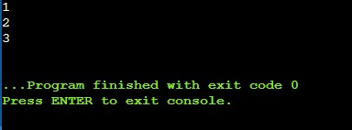

using namespace std;

class fun{

int x;

static int count; // shared by all objects

public:

void noOfFun(){ count++; }

void display(){ cout<<count<<endl; }

};

int fun::count = 0;

int main()

{

fun p, q, r;

p.noOfFun();

p.display();

q.noOfFun();

q.display();

r.noOfFun();

r.display();

// p.display();

return 0;

}

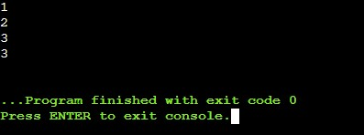

**Question 5(a)**

#include <iostream>

using namespace std;

class fun{

int x;

static int count; // shared by all objects

public:

void noOfFun(){ count++; }

static void display(){ cout<<count<<endl; }

// The member used in static function must also be static.

};

int fun::count = 0;

int main()

{

fun p, q, r;

p.noOfFun();

p.display();

q.noOfFun();

q.display();

r.noOfFun();

r.display();

p.display();

return 0;

}

**Question 5(b)**

#include <iostream>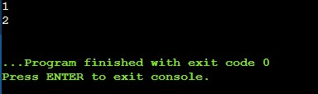

using namespace std;

class countObj{

static int count;

public:

countObj() { count++; }

void noOfObj() { cout<<count<<endl; }

};

int countObj::count = 0;

int main()

{

countObj p;

p.noOfObj();

countObj q;

q.noOfObj();

return 0;

}

***Assignment 5a***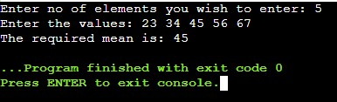

**Question 1**#include <iostream>

using namespace std;

class mean{

int n;

int *arr = new int [n];

public:

void getdata();

friend float avg(mean obj);

};

void mean::getdata(){

cout<<"Enter no of elements you wish to enter: ";

cin>>n;

cout<<"Enter the values: ";

for(int i=0;i<n;i++)

cin>>arr[i];

}

float avg(mean obj){

float sum=0;

for(int i=0; i<obj.n; i++)

sum += obj.arr[i];

float avg_n = sum/obj.n;

return avg_n;

}

int main()

{

mean x;

x.getdata();

cout<<"The required mean is: "<< avg(x);

return 0;

}

**Question 2**

#include <iostream>

using namespace std;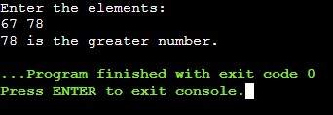

class compare{

float x, y;

public:

void getdata();

friend float great(compare obj);

};

void compare::getdata(){

cout<<"Enter the elements: "<<endl;

cin>>x>>y;

}

float great(compare obj){

if(obj.x > obj.y)

return (obj.x);

else

return (obj.y);

}

int main()

{

compare x;

x.getdata();

cout<<great(x)<<" is the greater number.";

return 0;

}

**Question 3**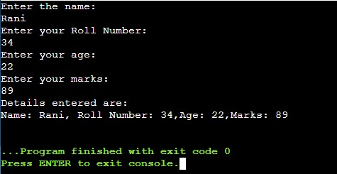

#include <iostream>

using namespace std;

class stu_details{

char name[30];

int roll_no;

int age;

int marks;

public:

void get_details();

friend void display(stu_details obj);

};

void stu_details::get_details(){

cout<<"Enter the name: "<<endl;

cin>>name;

cout<<"Enter your Roll Number: "<<endl;

cin>>roll_no;

cout<<"Enter your age: "<<endl;

cin>>age;

cout<<"Enter your marks: "<<endl;

cin>>marks;

}

void display(stu_details obj){

cout<<"Details entered are: "<<endl;

cout<<"Name: "<<obj.name<<", Roll Number: "<<obj.roll_no<<",Age: "<<obj.age<<",Marks: "<<obj.marks<<endl;

}

int main()

{

stu_details x;

x.get_details();

display(x);

return 0;

}

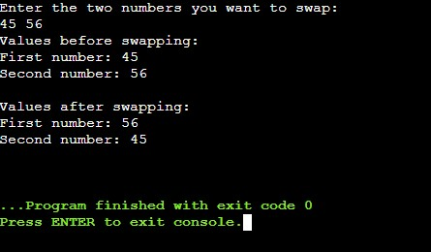

**Question 4**

#include <iostream>

using namespace std;

class num_swap{

int x, y;

public:

void getdata();

void display();

friend num_swap swapping(num_swap);

};

void num_swap::getdata(){

cout<<"Enter the two numbers you want to swap: "<<endl;

cin>>x>>y;

}

void num_swap::display(){

cout<<"First number: "<<x<<endl;

cout<<"Second number: "<<y<<endl;

cout<<endl;

}

num_swap swapping(num_swap obj){

num_swap temp;

temp.x=obj.y;

temp.y=obj.x;

return temp;

}

int main()

{

num_swap x1;

x1.getdata();

num_swap x2 = swapping(x1);

cout<<"Values before swapping: "<<endl;

x1.display();

cout<<"Values after swapping: "<<endl;

x2.display();

return 0;

}

**Question 5**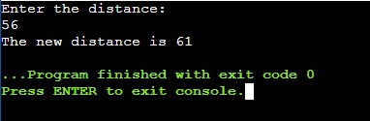

#include <iostream>

using namespace std;

class Distance {

private:

int meter;

public:

Distance(): meter(0) { }

Distance(int x) { meter = x; }

// friend function

friend void addFive(Distance obj);

};

void addFive(Distance obj){

obj.meter += 5;

cout<<"The new distance is "<<obj.meter;

}

int main()

{

int d0;

cout<<"Enter the distance: "<<endl;

cin>>d0;

Distance d(d0);

addFive(d);

return 0;

}

**Question 6**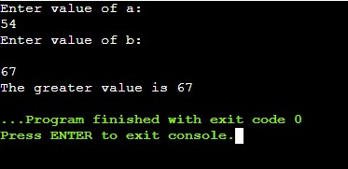

#include<iostream>

using namespace std;

class one;

class two;

class one{

int a;

public:

one() { cin>>a; }

friend int cal(one a,two b);

};

class two{

int b;

public:

two() { cin>>b; }

friend int cal(one a,two b);

};

int cal(one x,two y){

return (x.a>y.b) ? x.a : y.b;

}

int main(){

cout<<"Enter value of a: "<<endl;

one x;

cout<<"Enter value of b: "<<endl;

two y;

cout << "The greater value is " << cal(x,y);

}

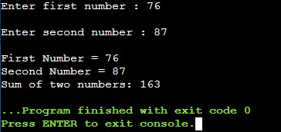

**Question 7**

#include<iostream>

using namespace std;

class mean{

private:

int a;

int b;

public:

void getdata(){

cout<<"Enter first number : ";

cin>>a;

cout<<"\nEnter second number : ";

cin>>b;

}

friend void greatest(mean obj);

};

void greatest(mean obj){

cout<<"\nFirst Number = "<<obj.a<<"\nSecond Number = "<<obj.b;

int sum =0;

sum = obj.a + obj.b;

cout<<"\nSum of two numbers: "<<sum;

}

int main(){

mean D;

D.getdata();

greatest(D);

return 0;

}